

TABLE OF CONTENT
- ACKNOWLEGDMENT
- PROJECT CERTIFICATION
- INTRODUCTION To Travel Smart
- REQUIRMENT SPECIFICATION
- (A) HARDWARE REQUIRMENT
- (B) SOFTWARE REQUIRMENT
- SNAPSHOT

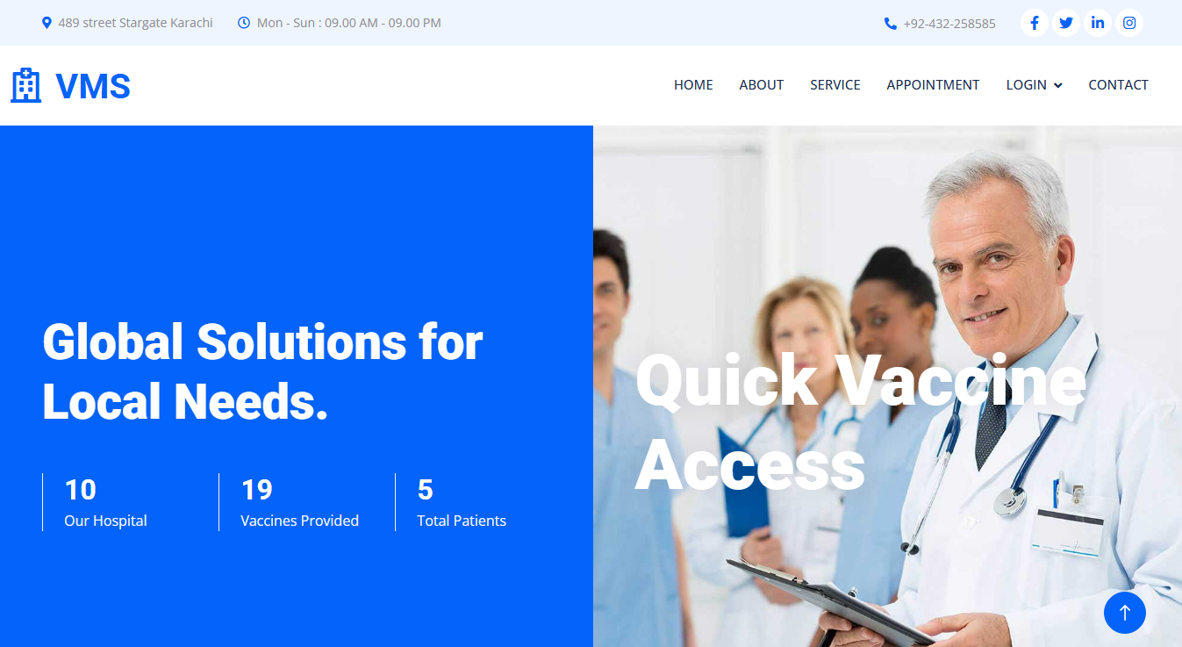
PHP E-PROJECT
SUBMITTED TO:
eprojects@aglsm.com
Project Instructor:
Ms. Laiba Shahid
CURRICULAM CODE:
7144

MEMBERS
Ali Abdullah
Student I’D: 1595693

ACKNOWLEGDMENT
We are thankful to Almighty, ALLAH that by his grace we have been successful. We have tried our best to take all relevant important topics in consideration so that this project may become comprehensive.
This is our Second Year Semester E-Project. We have tried our best & struggled for a better outlook to come. We choose to make Vaccine Management System (VMS) as for our project.
We earnestly hope that this project will provide all the necessarily information required for the user to fulfill their inspiration. However, suggestions for improvement of the project will be thankful received & acknowledge
Thank you.

PROJECT CERTIFICATION
This is to certify that,
Ali Abdullah has successfully designed
“Vaccine Management System (VMS)”
Date of issue:
20-June-2025
Authorized Signature: Ms. Laiba Shahid

INTRODUCTION TO THE VMS

In the existing system, Vaccines are provided for infants and children under teenage by various aspects such as by attending school manually and there is a chance that some of the children’s and infants may miss the opportunity of getting vaccinated due to some mandatory reasons. Which leads to loss of life or gets affected by various diseases such as polio… etc? This is a time delay process to wait for each and every one all over the places.

REQUIREMENTS:

Admin
- All child details
- Date & time of vaccination
- Report of vaccination
  - Child, Vaccination (Date wise report)
- List of vaccine
  - available or unavailable
- Request from parents
  - Approve or Reject
- Add Hospital
  - Update/Delete Hospital
- List of hospitals
- Booking Details

Parent
- Register & Login
- Details of child
- Vaccination Dates
- Book Hospital
- Request for hospital
- Report of vaccination taken
- My profile

Hospital
- Register & Login
- Update Vaccine status

HADWARE REQUIREMENTS:
- A minimum computer system that will help you access all the tools in the courses is a Pentium 166 or better
- 128 Megabytes of RAM or better

SOFTWARE REQUIRMENT:
- PHP
- MySQL
- PERL
- Apache

Project Duration
- Analysis – 25 Hrs.
- Design – 19 Hrs.
- Development – 100 Hrs.
- Testing – 36 Hrs.
- Documentation – 6Hrs.

Analysis | Design | Development | Testing

20-Jun-25 To 21-Jun-25

26-Jun-25 To 27-Jun-25
22-Jun-25 To 22-Jun-25

22-Jun-25 To 26-Jun-25

Documentation | Finalization

29-Jun-25 To 10-Jun-25
28-Jun-25 To 28-Jun-25
S No. | Task | Actual Start Date | Actual Days | Teammate Name | Status
1 | Analysis | 20/07/25 | 1 | Ali | Completed
2 | Design | 22/07/25 | 1 | Ali | Completed
3 | Development | 23/07/25 | 4 | Ali | Completed
4 | Testing | 26/07/25 | 5 | Ali | Completed
5 | Documentation | 28/07/25 | 1 | Ali | Completed
6 | Finalization | 29/07/25 | 12 | Ali | Completed
TASK SHEET

SNAPSHOTS



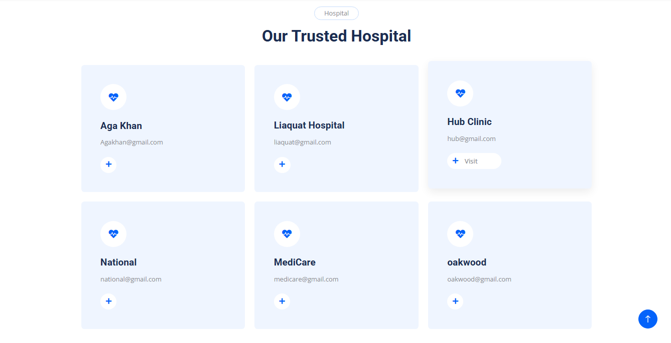



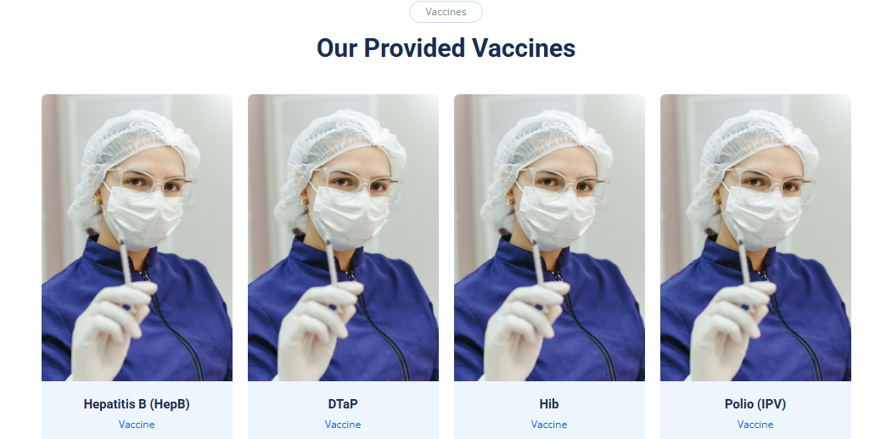
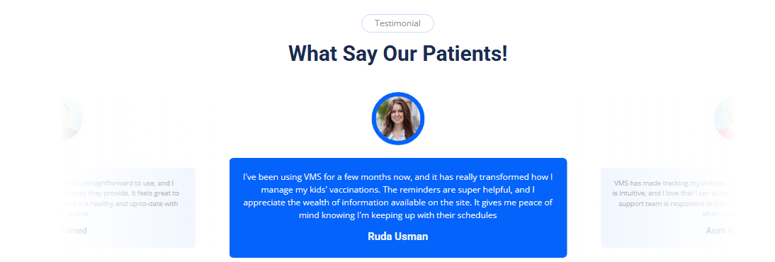
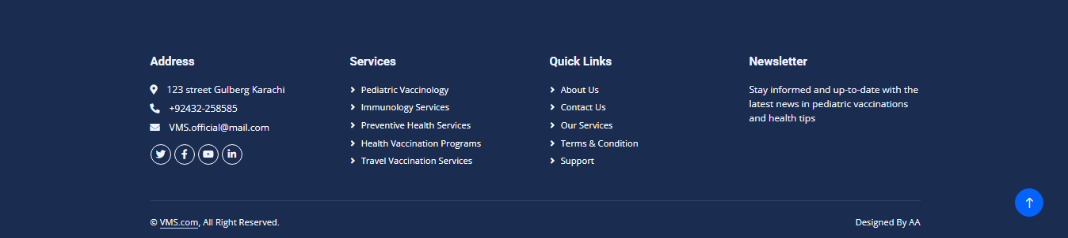
THE END

